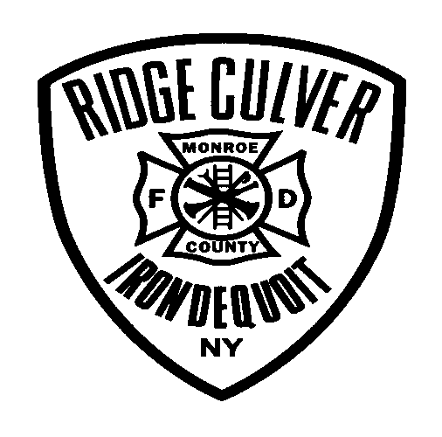RIDGE-CULVER FIRE DISTRICT

2960 Culver Road Rochester, New York 14622

Phone: (585) 467-4241

EXPLORER DIVISION

Social Media / Photo Consent Form

The Ridge Culver Fire District would like your permission to use images taken of your child while training and at Exploring events to showcase their activities with our fire department and the Exploring Program. These images will be highlighted on our website, Facebook, and other social media outlets for recruitment, fundraising and other associated Explorer Post and Fire Department purposes.

Declaration:

I grant permission photographs and images of me/my child in the formats indicated above.

Childs name: ______________________________

Parents name: ______________________________

Parents signature: ______________________________

Date: __________