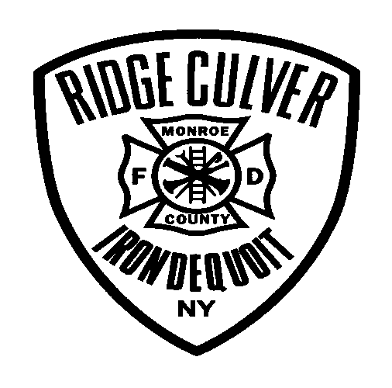RIDGE-CULVER FIRE DISTRICT

2960 Culver Road Rochester, New York 14622

Phone: (585) 467-4241

EXPLORER DIVISION

Field Trip Consent Form

I (we): ______________________________ authorize my child: ________________________ to travel with the advisors of the Ridge Culver Fire District Explorer Post. This may include travel in personal or fire district owned vehicles.

In addition, I (we): _________________________ authorize consent to treat any necessary routine medical needs and any emergency medical treatment during the aforementioned trip(s)

Medical concerns if any: _________________________________________________________

Childs name: ________________________________

Parents name: _______________________________

Parents signature: ____________________________

Parents signature: ____________________________

Date: __________